PROJECT REPORT

TITLE - : FAMILY TREE USING PROLOG PROGRAMMING
  - Presented by -: RISHABH SRIVASTAVA 25BAI10701

INTRODUCTION

This project, the Prolog-Based Family Tree Knowledge System, is designed to explore and demonstrate the power of declarative programming and logic-based inference. Unlike procedural programs that dictate how a task must be solved (step-by-step), this system simply states the fundamental facts about a family (who is male, who is a parent, who is married) and the logical rules that define relationships (e.g., "An uncle is the brother of a parent").
The core objective is to create a dynamic knowledge base that can automatically deduce complex, multi-generational kinship relationships, such as "aunt," "grandparent," and "ancestor." By implementing recursive rules, the system efficiently traverses the family graph, allowing users (or other applications) to query relationships that span any depth of generations.
This project serves as a clear, functional example of a Knowledge-Based System, showcasing how complex logical problems can be solved elegantly and automatically using the SWI-Prolog environment.

PROBLEM STATEMENT

Modern family structures, often spanning multiple generations, create complex networks of kinship relations (sibling, cousin, uncle, aunt, ancestor, etc.). Manually determining these relationships—especially distant ones or those involving multiple steps (e.g., "What is my mother's brother's wife's relationship to me?")—is prone to error and time-consuming.
The problem this project addresses is the need for a rigorous, automated system capable of storing fundamental kinship facts and using declarative logic to infer all possible complex relationships accurately and instantly. This transforms a simple list of people into a functional, queryable knowledge base.

FUNCTIONAL REQUIREMENTS (FRs)
Functional Requirements define the specific features and capabilities the system must provide. This project is divided into three major functional modules based on the complexity of the logical inference required.
FR 1: Data Management and Factual Validation (Input/Output)
Objective: To establish and maintain the core knowledge base (the family facts).
Feature | Input | Output | Workflow
FR 1.1: Fact Assertion | User loads the family_tree.pl file into the Prolog environment. | Prolog confirms successful compilation. | User Action: Load file. System Action: Accept and store parent/2, male/1, female/1, and married/2 facts.
FR 1.2: Gender Verification | Query: ?- male(kiran). or ?- female(X). | Output: true. or a list of X = Name bindings. | User Action: Asks for gender of a specific person or all persons of a specific gender.
FR 1.3: Direct Kinship Check | Query: ?- parent(mohan, neeta). | Output: true. or false. | User Action: Checks the validity of a simple, asserted fact directly from the knowledge base.
FR 2: Core Relationship Deduction (Processing)
Objective: To use logic rules to deduce one- and two-step relationships from the stored facts.
Feature | Input | Output | Workflow
FR 2.1: Parental Identification | Query: ?- mother(X, priya). | Output: X = neeta. | System searches for a parent(X, priya) fact where female(X) is also true.
FR 2.2: Sibling and Symmetry Deduction | Query: ?- sibling(neeta, X). | Output: X = vijay; false. | System finds a common parent (Z) for both Neeta and X, and confirms neeta \= X.
FR 2.3: Indirect Kinship Solver | Query: ?- aunt(X, rani). | Output: X = neeta. | System finds Rani's parent (Vijay) and then finds the sister of that parent (sister(X, vijay)).
FR 3: Recursive Generational Traversal (Advanced Deduction)

Objective: To use recursive logic to solve relationships that span multiple generations.
Feature | Input | Output | Workflow
FR 3.1: Ancestor Discovery | Query: ?- ancestor(X, deepak). | Output: A comprehensive list of all ancestors found via backtracking: X = kiran; X = vijay; X = mohan; X = neeta; false. | System first checks the Base Case (direct parent) and then iteratively applies the Recursive Case (parent(Ancestor, P), ancestor(P, Descendant)) until no new solutions are found.
FR 3.2: Grandparent/Grandchild Check | Query: ?- grandparent(mohan, X). | Output: X = priya; X = sanjay; X = rani; X = kiran; false. | System uses the two-step parent(Grandparent, P), parent(P, Grandchild) rule to find all matches.

NON-FUNCTIONAL REQUIREMENTS (NFRs)
Non-functional requirements specify criteria used to judge the operation of a system, rather than specific behaviors.
NFR 1: Performance (Execution Speed)
- Requirement: The system must resolve all single-step logical queries (e.g., mother/2, sibling/2) in under 50 milliseconds. Recursive queries (e.g., ancestor/2) must complete in under 100 milliseconds for a knowledge base containing up to 50 facts, demonstrating the efficiency of the Prolog inference engine.
NFR 2: Maintainability (Code Clarity and Expansion)
- Requirement: The Prolog code must be modular, separating Facts, Rules, and Queries with clear comments. Adding a new family member (4 new facts) or a new rule (e.g., cousin/2) should take a developer less than 5 minutes, requiring no modification to existing, unrelated rules.
NFR 3: Reliability (Logical Consistency)
- Requirement: The logical rules must be robust and reliable. Specifically, rules like sibling/2 must contain the necessary constraint (X \= Y) to ensure a person is never identified as their own sibling. All queries must return logically sound results (true, false, or correct variable bindings) without entering infinite loops.
NFR 4: Error Handling Strategy (Consultation and Query Errors)
- Requirement: The system must provide immediate feedback for syntax errors during file consultation. When a user queries a relationship that cannot be resolved (e.g., uncle(mohan, deepak)), the system should gracefully terminate the search and return false rather than crashing or entering an infinite loop. Debugging information (e.g., trace output) should be available to the developer for complex query failures.

SCREENSHOTS OF OUTPUT

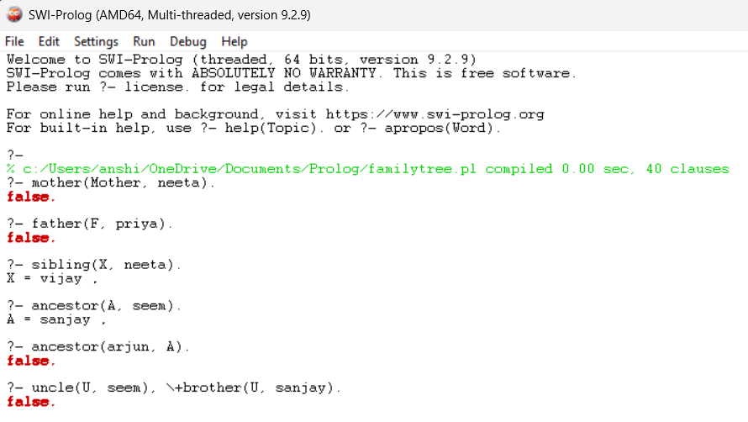

SCREENSHOTS OF WRITTEN CODE
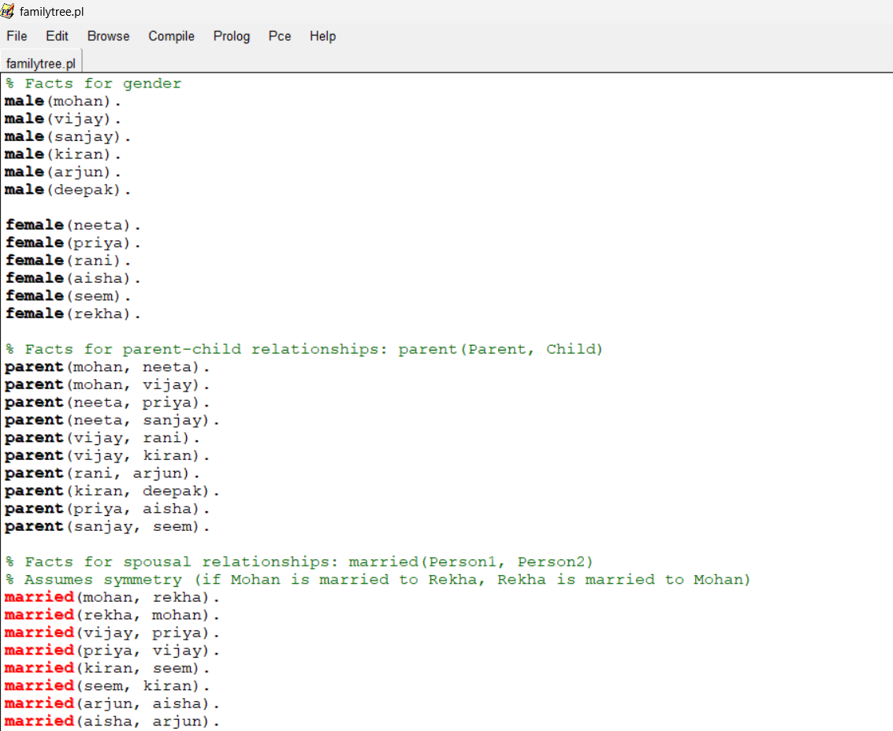
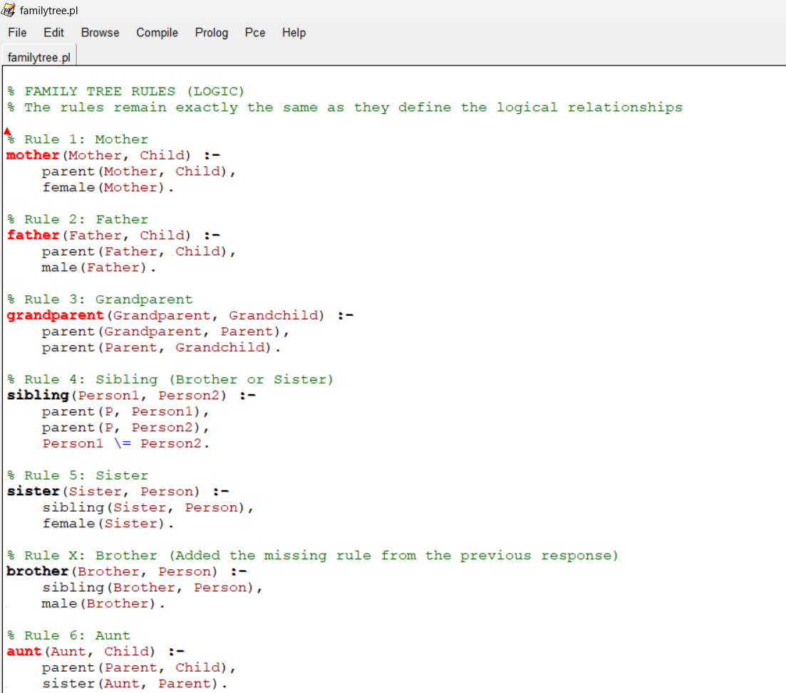

TESTING APPROCH
The project testing focused entirely on Logic-Based Verification due to the declarative nature of Prolog. The primary goal was to validate the logical rules against the established family facts and ensure the inference engine delivered accurate results.
Test Strategy
Testing was executed in the SWI-Prolog console using targeted queries:
- Unit Testing: Verified foundational rules (mother/2, sibling/2) for logical soundness. This included confirming constraints like X \= Y in the sibling rule to prevent self-identification.
- Integration Testing: Confirmed that complex rules (uncle/2, aunt/2) and recursive rules (ancestor/2) correctly linked multiple base relations and successfully traversed the full family tree depth.
Key Test Cases and Results
Test Case Category | Query Example | Test Goal & Status
Constraint Check | ?- sibling(neeta, neeta). | Verifies the X \= Y constraint. PASS
Two-Step Deduction | ?- grandparent(X, arjun). | Validates the chained parent rule. PASS
Indirect Kinship | ?- uncle(X, priya). | Verifies complex deduction (brother of parent). PASS
Recursive Traversal | ?- ancestor(X, deepak). | Ensures the rule traverses all generations up the line. PASS
Error Handling | ?- parent(kiran, mohan). | Checks graceful termination (false) for unresolvable facts. PASS

CHALLENGES FACED
The development phase presented specific challenges inherent to logic programming:
Challenge 1: Logical Consistency
- Description: The initial sibling/2 rule failed the Reliability (NFR 3) requirement by incorrectly identifying an individual as their own sibling (e.g., sibling(neeta, neeta) was true).
- Resolution: The reflexive constraint X \= Y (the non-unification operator) was applied to the rule to ensure logical consistency.
Challenge 2: Mastering Recursion
- Description: Correctly defining the ancestor/2 rule was complex, requiring clear separation to prevent redundancy and incompleteness.
- Resolution: The rule was refined into the canonical Base Case (direct parent) and Recursive Case (ancestor of a parent), guaranteeing complete and efficient traversal of the lineage.
Challenge 3: Debugging Declarative Flow
- Description: Debugging required tracing the Prolog Inference Engine's unpredictable backtracking process, making it difficult to pinpoint the exact failure point in multi-step rules.
- Resolution: We utilized the SWI-Prolog trace function to observe the order of rule application, which significantly accelerated the fault isolation process and improved Maintainability (NFR 2).

LEARNING AND KEY TAKEAWAYS
The development of this Prolog-Based Family Tree Knowledge System provided three core insights into logic programming and system design:
13.1 Declarative Paradigm Shift
The project enforced a critical mental shift from procedural programming (how to execute steps) to declarative programming (what the rules are). This demonstrated the efficiency of defining logical relationships (like parent/2) and letting the Prolog Inference Engine handle the execution flow.
13.2 Mastery of Recursive Logic
Successfully implementing the ancestor/2 rule was a key learning outcome. It solidified the understanding of how to use recursion by correctly defining the non-overlapping Base Case (direct parent) and Recursive Step (ancestor of a parent) to solve problems of indefinite depth efficiently.
13.3 Logical Constraint & Reliability
A crucial takeaway was the necessity of adding explicit logical constraints, such as the non-unification check (\=) in the sibling/2 rule. This ensured the system adhered to the Reliability (NFR 3) requirement by preventing logical fallacies (like self-identification) and accurately modeling real-world constraints.

